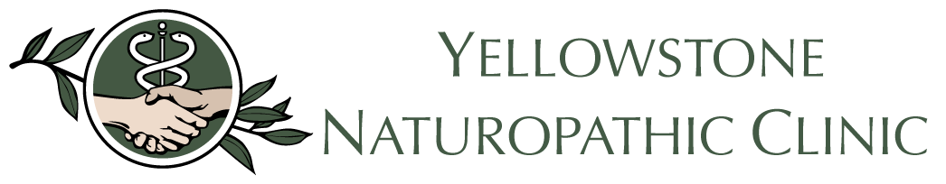

Associate Naturopathic Physician,
Yellowstone Naturopathic Clinic is interested in highering a full-time experienced naturopathic doctor to join our cutting-edge clinic in Billings, Montana. Applicant must be passionate about treating the whole person, addressing the root cause of illness and have a strong interest in injection therapies.
Yellowstone Naturopathic Clinic is well established in the Billings community since 1992 and located in the medical corridor. We work collaboratively with many of the local doctors and practice a wide variety of modalities to ensure our patients receive the best all-inclusive care. YNC is committed to quality patient care, a collaborative approach, and top-notch professionalism.
The clinic is a general family practice specializing in woman’s health, SIBO, gastrointestinal issue, autoimmune disease, pediatrics, Facial PRP, specialized weight loss programs, IV therapy, hydrotherapy, PRP, Stem Cell, Prolotherapy, micro needling, and featuring a full medicinary.
What sets us apart from other clinics? We have an all-encompassing facility under one roof. Along with our wonderful naturopathic doctors, we feature an integrative chiropractor, acupuncture, cranial Sacral therapist, massage therapists as well as a full support staff to assist you with your needs. Please visit our website for more about YNC and the treatment modalities we offer.
If you are interested in practicing as a Primary care Physician, we welcome your inquiry. We particularly desire an associate who has a strong interest, and some expertise, in Regenerative Injection Therapies, which we have offered at our clinic for over 25 years.
Compensation includes:
Base salary + Personal Production Bonus
Paid Malpractice
Medical and retirement benefits
Paid Vacation

To apply please send your CV to jbell@yncnaturally.com
Job Type: Full-time
Experience: Clinical: 4 years (Preferred)
License: AANP (Required)

